Would you like to sponsor a hedgehog?
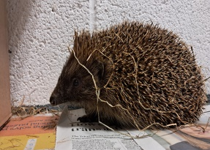 |  | Bruno was found in a car park. He had been attacked by a predator and had one wound under an arm pit and another behind his left ear. It is possible that his injuries were as a result of scrambling though dense undergrowth during foraging. He is a very huffy, bad tempered hog with plenty of attitude.
Bella was admitted with an injury to her left eye and a torn ear, possibly the result of a predatory attack. Her eye is a cause for concern and her navigation ability will be checked to find is she has sight in the injured eye. She will require careful nursing and medication |  |  | 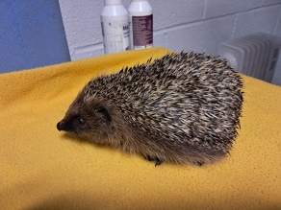
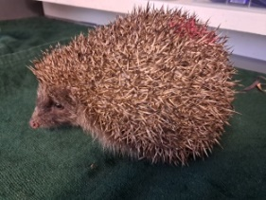 | Primrose arrived as a small hoglet weighing 95 grams. She was found out wandering during the day and with no sign of an adult or a nest Primrose would not have survived. Primrose will need to stay until she reaches adulthood. And can be released to a safe environment.

To sponsor one of these hedgehogs for just £30 for a year you can pay by PayPal or by sending the payment to us - with a cheque made out to “Prickles Hedgehog Rescue” for £30.
Whichever you decide to do, please download the sponsor form , fill it in, indicating which hedgehog you would like to Sponsor and send to:
Prickles Hedgehog Rescue,
3A Wessex Court,
Wessex Business Park,
Wedmore Road,
Cheddar, Somerset, BS27 3EJ
If you are a UK taxpayer, please complete the Gift Aid section - your donation will be worth even more to us that way.
Or you can become a ‘Friend of Prickles’ by setting up a Standing Order to pledge a monthly amount to Prickles.
In return you will receive a monthly E-News by E-mail keeping you updated with hoggie news from the Hogspital.
Thank you for your support. Together we can make a difference.

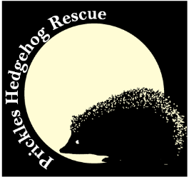
Sponsor a Hedgehog Form
Please return to Prickles Hedgehog Rescue, 3A Wessex Court, Wessex Business Park,
Wedmore Road, Cheddar, Somerset, BS27 3EJ

Date: _________________

Name of donor: ___________________________________________________

Name of hedgehog you want to sponsor: _______________________________

Address: ________________________________________________________________________
________________________________________________________________________________
________________________________________________________________________________
Email Address____________________________________________________________________

Payment method (tick): Cheque □ Cash □ On-line transfer/BACS □ PayPal □
Cheques to be made out to ‘Prickles Hedgehog Rescue’. Please do not send cash by post.

Amount: □ £30 for individual hedgehog sponsorship
□ £______ other amount for multiple sponsorships

Is this a gift? (please circle) Yes / No

If yes please fill out the section below; the 6 month and 12 month updates will be sent directly to the gift recipient.

Gift details
Recipient Name: __________________________________________________________________

Recipient Address: _________________________________________________________________
_________________________________________________________________________________
__________________________________________________________________________________________________________________________________________________________________

Reason for gift: ___________________________________________________________________

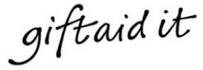
Gift Aid Declaration (UK tax-payers only)
If you are a UK tax payer, every £1 you give with Gift Aid is worth £1.25 to Prickles Hedgehog Rescue, at no extra cost to you. All you need to do is sign the declaration below. If you are a higher-rate taxpayer, you can also claim relief in your Self-Assessment tax return.
I am a UK taxpayer and would like Prickles Hedgehog Rescue to treat all donations I make from the date of this declaration until I notify Prickles Hedgehog Rescue otherwise as Gift Aid donations. I note that I must be paying an amount of Income and/ or Capital Gains Tax at least equal to the amount that Prickles Hedgehog Rescue will reclaim on my donation(s) in the relevant tax year (currently 25p for every £1 donated).
Signed:_______________________________________________ Date:____________________________
- You can cancel your declaration at any time by notifying Prickles Hedgehog Rescue
- If your circumstances change and you no longer pay the required amount of tax, you must cancel your declaration.
- Please notify Prickles Hedgehog Rescue of any changes to your name and/ or address while your declaration is active.

